Working With Futura and Futura Sound Panels

The Futura® and Futura Sound panels are highly versatile wall or ceiling panel systems made of bamboo and measuring 3/4” x 47.75” x 47.75”(19mm x 1.213m x 1.213m). Futura and Futura Sound panels are configurable regardless of their orientation and can be rotated and installed in any of four different directions.

As with any panel system, the specific installation method will vary widely based on site-specific factors and customer preferences. In this document we identify general considerations for the installer to consider as an appropriate installation method is identified for specific jobsite conditions.

The two most common methods for wall installation of these panels are removable hanging systems, and blind face screwing. We consider these installation approaches below.

Prepare Your Installation Substrate

Make sure your installation substrate is flat and plumb. If necessary, true the wall to such conditions.
No wall surface is perfectly flat and level, and any unevenness can telegraph through the panel installation. For a successful installation, it is imperative that you first make sure that the installation substrate is flat and plumb, and capable of supporting the panels.

A flat substrate for panel installation can be achieved through a variety of approaches including the use of appropriately placed shims or wood furring strips, with the ultimate choice being at the discretion of the installer, dependent on various site conditions and installation preferences. The intent is to level and plumb your wall in preparation for panel installation.

If using furring strips, a typical application is to use wood furring strips with a minimum thickness of 1/8”, and approximately 2-3” wide, with these strips securely fastened to the wall in combination with your installation hardware and extended horizontally along the wall.

When installing furring strips, you must shim and level them to the wall so that when completed the strips are even to each other vertically and horizontally, providing a consistently flat and even substrate for installation. Alternatively, depending on the condition of your wall, you may instead use appropriately placed shims to help achieve a flat and even installation substrate.

Panel Hanging Systems

A variety of panel hanging systems can be used in a successful installation. Many installers have successfully used the panel hanging hardware manufactured by Monarch Metals for a sturdy and easy to implement installation system. We discuss installation using these Monarch Z Clip system but these comments can also generally apply to other hanging systems.

Extensive information on the Z Clip system is available at the Monarch web site, including for selection of appropriate Z Clips (www.monarchmetal.com/z-clip-selector-tool/), as well as detailed installation information, and a helpful video on panel installation (https://www.monarchmetal.com/resources/faqs/). We recommend that prior to any installation you review various instructional material available through Monarch for detailed specifications and instructions for use of various Z Clips as may be appropriate to your particular installation needs.

The Monarch Z Clip system is made of aluminum and available in a variety of projection and lift off measurements. Several installation options are available, including clip-to-rail-and-rail to rail, which are discussed in this document.

For reference, Z Clips measuring 1.5” wide by 2” high are available pre-drilled for installation. The Z Clips are typically only installed on the back of the panels to be hung on the wall. Z Bars are continuous length rails of 72” or 144”, pre-drilled at 8” intervals and installed on the wall. The Z Bars are installed on the supporting wall, but may also be used on the back of the panels.

Installation with Monarch Z Clips or Z Bars

Measure twice, install once! Precise placement of installation hardware is vital for success.

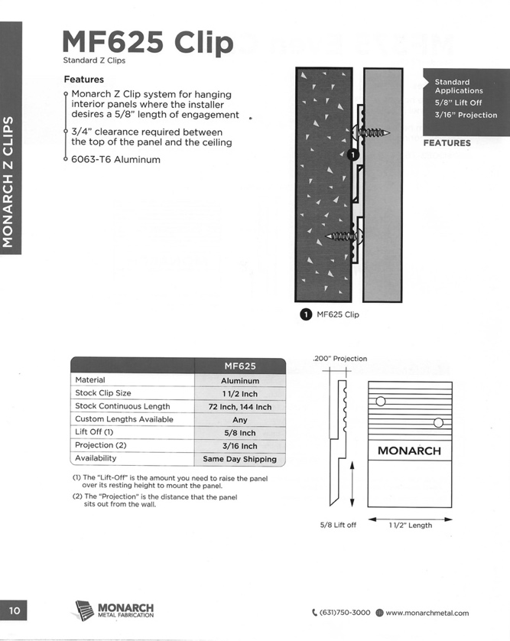 | Futura panels may be installed using Z Clips and Z Bars. Although the ultimate choice of the installation system is subject to the installer’s discretion, many customers have successfully used the Monarch MF625 Z Clips for installation. This Z Clip provides a 3/16” projection with a 5/8” lift off.
Most installers use a “rail to rail” approach with continuous length Z Bars installed on both the panels and the supporting wall. Alternatively, some installers prefer a “clip to rail” approach, with full-length Z Bars installed on the supporting wall and spanning the full width of the panels, and Z Clips installed at appropriate intervals on the panels. Ultimately, the installation method will depend on the installer’s specific knowledge of site conditions and installation requirements.

Regardless of whether you are installing Z Bars or Z Clips on the back of the panels, Z Bars should first be installed at appropriate intervals on the supporting wall to provide for installation of the panels. Generally, three rows of continuous length Z Bars should be installed on the wall with these rows evenly spaced across the installation.

Z Bar to Z Bar Installation: Once Z-Bars are placed on the supporting wall, then a minimum of three Z Bars per panel, each approximately 46” in length, installed and evenly spaced across the width of the back of a panel, are required for the installation of each panel. The top and bottom bars are typically installed 1-2” in from the left and right edges, and 1-2” down from the top and bottom edges, with the third bar placed at the panel’s center point, evenly spaced 1-2” in from the left and right.

The Z Bars should be screwed into the uncarved portion of the back of the panel; If the pre-drilled holes do not align with where you want to set your Z Bar, you may drill additional holes in the Z Bar as needed. A Z Clip or small portion of a Z Bar may be temporarily used as a shim the Z Bar to provide appropriate clearance space necessary to enable an easier installation of the panel.

Z Bar to Z Clip Installation: Alternatively, you may install Z Clips on the back of the panels instead of using Z Bars. A minimum of nine Z Clips should be used per panel. Three rows of Z Clips, with three Z Clips in each row evenly spaced and installed on the back of each panel. The first row of Z Clips should be approximately 2” down from top edge and 1” in from the left and right edges, a second row at bottom approximately 2” up from bottom edge and 1” in from left and right edges, and a third row at center point on the panel and approximately 1” in from the left and right edges.

The mounting Z Clips should carefully be installed on the panels such that they align with the Z Bars installed on the wall, with consideration for lift off requirements as specified by Monarch. Holding close to the top and bottom edges is important in allowing abutting panels to align.

Fasteners for Installation: Many installers have successfully used #8 x ½” (12.7mm) stainless steel, self-tapping, pan head screws to attach the Z Clips or Z Bars to the back of a panel. This type of screw will have enough hold without pushing through the front side of your panel.

Because the depth of the screw hole is minimal, set the screws by hand or use an appropriate drill clutch to avoid stripping out the screw hole.
Before setting screws, lay Z Clips or Z Bars in their proper position on the back of the panel. Draw a pencil line along the top and bottom edges of the clip or bar as well as mark the panel where the screw holes will go. Using an 1/8” (3.2mm) drill bit, carefully drill into the back of the panel to a depth of approximately ¼”(6.35mm) taking care not to drill thought the face of the panel.

In all cases, panels should be spaced appropriately to allow an adequate gap between the panels to accommodate dimensional change in the panels due to seasonal and ambient environmental conditions.

Installation with Blind Face Screws

Avoid gluing panels directly to the wall. This will impede seasonal movement in the panels and risk failure.
The Futura and Futura Sound panels have great screw hold characteristics, and when appropriate to a site, a site condition, or simply customer preference, the panels can be installed using a wooden grid structure leveled and fastened to the wall surface.

The Futura or Futura Sound panels can be carefully face-screwed through the carved grooves of the face design using a trim head, counter sunk screw that is color matched in order to help minimize the visual impact of using mechanical fasteners. Most installers have found the GRK brand of trim head, counter sunk screws to work well and this brand offers a range of color options as well. Additionally, color matched screws can be purchased directly from
Smith & Fong.

The installation grid should be constructed of a high grade, multiply plywood cut to strips measuring 3” wide by a minimum of 5/8” thick for the Futura panels, and a minimum of 1” thick for the Futura Sound panels (as further described in the next section.) These strips will run both vertically and horizontally where the panels meet, top to bottom and side to side. The strips should be placed center of the seam so that adjoining edges can be fastened to the same surface allowing them to seat and level to each other assuring a secure and snug fit.

An additional strip should then be placed horizontally at center point of each panel to allow an additional fastening surface. When you have completed your grid support system, there should be a screw-to surface on all four edges and at center line of the panel.

In the same way furring strips are used as shims in a Z Clip installation, these strips must also be shimmed as necessary to provide an even, flat, and level surface vertically and horizontally for fastening the Futura or Futura Sound panels.

Special Considerations for Installation of Futura Sound Panels

Futura Sound panels are installed in combination with an acoustic backing layer (e.g., our QuietWall™ backing material,) for additional acoustical abatement. To accommodate this backing layer, allowances must be provided for the installed panels to project off the wall by approximately an inch or more to allow for placement of acoustical backing material. This can be accomplished by using a wooden grid structure as described above, or through the use of Z Bars with sufficient standoff.

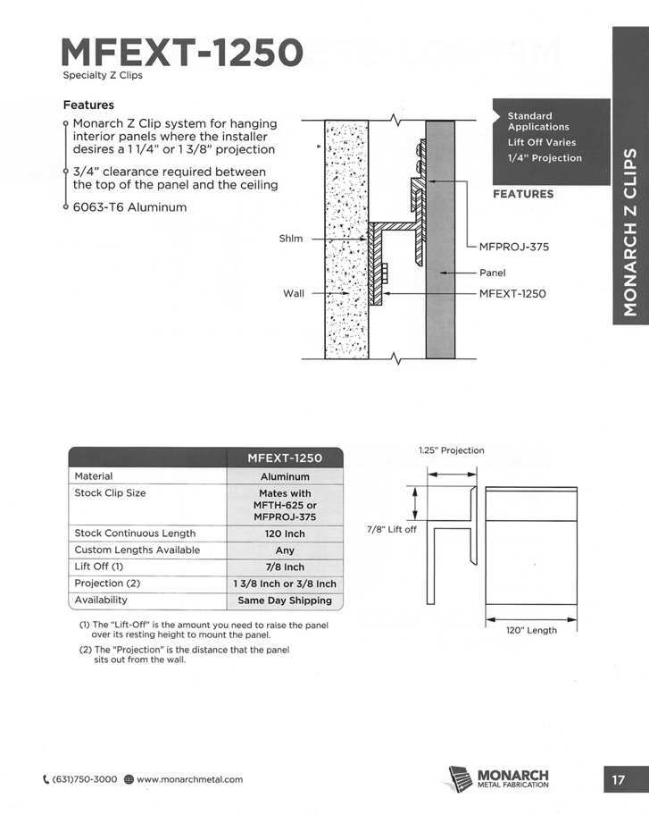 | To achieve the appropriate projection off the wall, special Z Clips or Z Bars must be used with a minimum standoff of 1”. The Monarch MFEXT-1250 Z Clip for example can provide an appropriate standoff (See diagram for MFEXT-1250).

Instead of a standoff Z Clip or Z Bar, furring strips can alternatively be used to provide a 1” standoff with low profile Z Clips used for installation. Installing the Z Clips on the wall before applying the acoustical fiberglass to the wall works best, with the panels hung on the existing Z Clip installation, and with the acoustical backing sandwiched between the wall and the back of the panel.

The QuietWall acoustical backing can be secured directly to the wall using a spray mount adhesive, or by simply and securely wedging the acoustical backing material snugly between the furring strips. To minimize the visual impact of the mounting hardware, please consider painting the hardware to match the acoustical backing material.
© 2024 Smith & Fong Co. All rights reserved. Monarch, Monarch Metal, and Z Clip are trademarks of Monarch Metal, Inc. Portions of this document feature third party content which is the property of its respective owner and is protected by applicable laws. Use of third party content to describe or identify third party products does not indicate any affiliation, sponsorship, or endorsement of Smith & Fong Co. or its products by such third parties.

